Ideation Phase
Define the Problem Statements

Date | 12 July 2026
Team ID | SWTID-2026-4732
Project Name | India's Agricultural Crop Production Analysis
Maximum Marks | 2 Marks

Customer Problem Statement:

PERSON:1
I am a small-scale farmer trying to make informed crop planning decisions, but I lack clear and accessible insights into historical agricultural data because existing reports are complex and difficult to interpret, which makes me feel uncertain about selecting the right crops and improving productivity.

PERSON
I am a Government Policy Analyst trying to identify regions with low crop productivity and improve agricultural policies, but I cannot easily analyze historical agricultural data because the information is scattered and difficult to visualize, which makes me feel less confident in making informed policy decisions.

PERSON
I am an agribusiness investor trying to make informed investment decisions in the agricultural sector, but I cannot easily identify profitable crops and high-performing regions because historical agricultural data is not presented in a clear and interactive format, which makes me feel uncertain about investment risks.

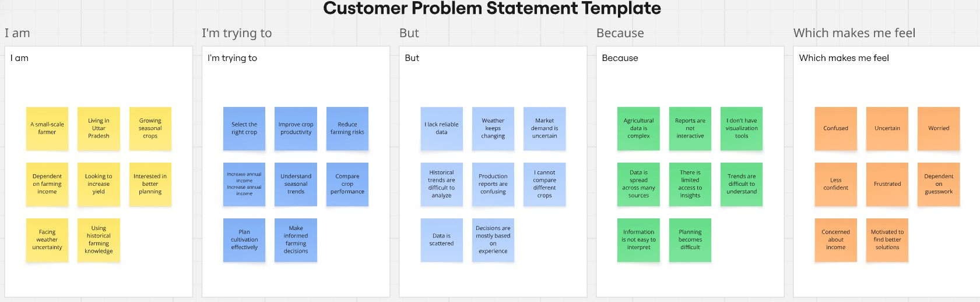

Example:
Problem  Statement (PS) | I am  (Customer) | I’m trying to | But | Because | Which makes me  feel
PS-1 | - A smallscale farmer  - Growing seasonal crops. | - Select the right crop  - Improve crop productivity | - I lack reliable data  - Weather keeps changing | - Agricultural data is complex  - Reports are not interactive | - Confused  - Uncertain
PS-2 | •Government  Policy Analyst  • Working for the Ministry of Agriculture | • Identify lowperforming regions • Improve agricultural productivity | •Agricultura l data is scattered • Reports are  difficult to analyze | • Data comes from multiple sources • Reports are mostly static | - Frustrated  - Responsible
PS-3 | •Agribusiness  Investor  • Investing in agriculture | - Identify highperforming crops  - Find profitable investment opportunities | •Agricultura  l data is difficult to interpret • Market trends are not clearly visualized | • Agricultural datasets are large and complex • Information is spread across multiple sources | • Curious to explore better insights • Motivated to make informed decisions

